Kyle Dugan

DeVry

ECT 345

Professor Sommer

21 Feb 2024

**ECT345**

**Module 8 - Final Course Project:**

**DTMF Tone Generation and Signal Analysis**

# Introduction

This course project introduces a practical application where sinusoidal signals are used to transmit information: A Touch-Tone phone keypad.

Telephone keypads generate **Dual-Tone Multi-Frequency (DTMF)** signals used to dial a telephone number.

When a key is pressed, the sinusoid of the corresponding row and column frequencies are generated and summed producing two simultaneous or dual tones.

As an example, pressing the **5 key** generates a signal containing the sum of the two tones at **770 Hz** and **1336 Hz**.

**Table 1: DTMF for Touch-Tone Dialing**

|  |  |  |  |
| --- | --- | --- | --- |
| Frequency (Hz) | **1209** | **1336** | **1477** |
| **697** | 1 | 2 | 3 |
| **770** | 4 | 5 | 6 |
| **852** | 7 | 8 | 9 |
| **941** | * | 0 | # |

**Note:** More information can be found by searching for “DTMF” or “Touch-Tone” on the internet.

This Final Course Project requires a three-step process which you will find below.

# Procedures:

## Step 1

Fill out the following Table 2 for **each key number.** Use the following formula.

Consider the Sampling Frequency **fs = 8000 Hz**. Calculate all seven digital frequencies and enter the low digital frequencies in the first column and high frequencies in the first row in Table 2. Please note that you can find low frequency and high frequency values for each key in Table 1 provided in the first page.

**Digital Frequency** **ΩL = 2π fL / fs ,** where fL  is the low frequency ( 697 to 941 Hz)

and **ΩH = 2π fH / fs,** where fH  is the high frequency ( 1209 to 1477 Hz)

Key Number Pair is **(ΩL, ΩH)**

## Step 2

Use **n= 0:1:99**. Number of samples considered.

**Write MATLAB code** for Dual Tone sound generation of each key from 0 to 9, using the above Table in Step 1.

Example: **d0 = cos** ( **ΩL * n) + cos** ( **ΩH * n)**

**d0 = cos** (**0.7391* n) + cos** ( **1.0493* n)**

1. Use **plot** commands for keys **0,2,4,8**; with proper x-label, y-label and title. Include all four plots in your report with your comments using subplot command.
2. Use **specgram** command for keys **1,3,7, 9**; with title only. Include all four specgrams in your report with your comments using subplot command.
3. Use **FFT** method to plot the **frequency spectrum** of keys **1, 5, 6, 9**; with proper x-label, y-label and title. Include all four frequency spectra in your report with your comments using subplot command.

## Step 3

1. Just pick up any **seven-digit phone number** (e.g. 306 – 4283). This phone number is from DeVry Helpdesk.

Use **s= zeros(1, 100)** The space between each key press.

>> **phone= [ d3 s d0 s d6 s d4 s d2 s d8 s d3]**

Use **specgram** only command to see the sound pattern of your phone number and print in your report.

1. **To verify the results of specgram diagram:** Calculate the two frequencies (low and high) by the following example. Just pick up one number out of seven-digit phone number as shown above.

Based on the results of our experiment and observations made during the experiment, we can calculate the **Key 4** frequencies (lower and higher) according to the DTMF Table 1.

From the results of the spectrum for each key tone, one can be able to estimate the frequency of the key because we know that

ω = 2 fs ( Ω/2) for small values of Ω.

Therefore**, f = Ω fs / 2** Remember the digital frequency is normalized ( Ω = 0 to 1)

From the specgram as shown in figure below (**Touch-Tone for Key 4**) the digital frequency can be estimated to be **0.192** witha sampling frequency of 8000 Hz, hence the frequency for that key is:

**f L = Ω fs / 2** = (0.192 * 8000)/2 = **786 Hz**. This is very close to 770 Hz for Key 4.

Similarly, the digital frequency of the high frequency component can be estimated to be **0.303,** hence the high frequency for that key is:

**f H = Ω fs / 2** = ( 0.303 * 8000)/2 = **1212 Hz**. This is very close to 1209 Hz for Key 4.

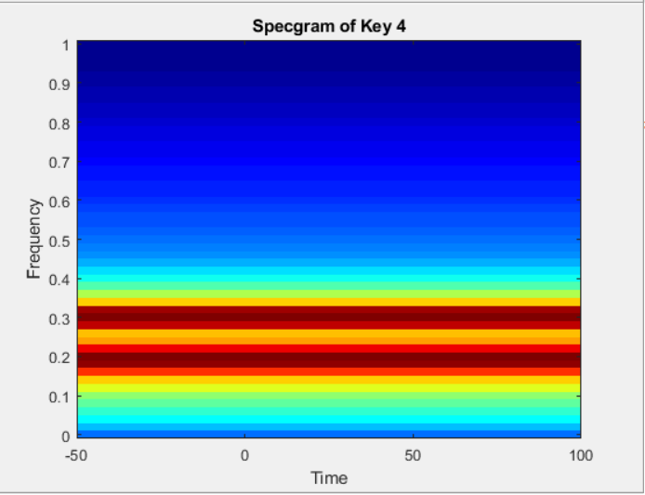

Here you have noticed that the low-frequency is very close to **0.2** along the normalized frequency axis (Brown color horizontal line) and the high-frequency is very close to **0.3** along the normalized frequency axis (another Brown color horizontal line). These numbers are estimated values.

1. **Pick up one number (other than 4) and verify** and test the results by estimated values of digital frequencies and compare the data with the Table 1.

# REPORT:

**Step 1:**

Table 1

|  |  |  |  |
| --- | --- | --- | --- |
| Frequency (Hz) | **1209** | **1336** | **1477** |
| **697** | 1 | 2 | 3 |
| **770** | 4 | 5 | 6 |
| **852** | 7 | 8 | 9 |
| **941** | * | 0 | # |

Low Frequency

High Frequency

**Table 2**

|  |  |  |  |
| --- | --- | --- | --- |
| Frequency (rad) | **0.9495** | **1.0493** | **1.1600** |
| **0.5474** | 1 | 2 | 3 |
| **0.6048** | 4 | 5 | 6 |
| **0.6692** | 7 | 8 | 9 |
| **0.7391** |  | 0 |  |

**Step 2:**

Step 2a Graph:

The graphs show the samples that are taken for each digit based off of the Cosine equation in the step 2. The amplitude of the plots is between -2 and 2. The samples are between 0 and 100.

Step 2b Spectrogram:

The spectrograms show the bands of frequencies generated for each digit used. We have two frequencies for each digit used.

Step 2c FFT Graph:

The FFT Plots show the magnitue for each digit for the frequencies used.

**Step 3:**

Step 3a:

Step 3b:

Frequency points for Digit 5.

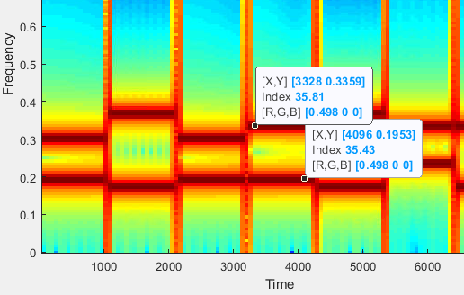

Verifying the two values with the frequencies listed in Table 1 for Digit 5.

High Frequency: 0.3359

fs = 8000 Hz

Low Frequency: 0.1953

fs = 8000 Hz

**Table 1**

|  |  |  |  |
| --- | --- | --- | --- |
| Frequency (Hz) | **1209** | **1336** | **1477** |
| **697** | 1 | 2 | 3 |
| **770** | 4 | 5 | 6 |
| **852** | 7 | 8 | 9 |
| **941** | * | 0 | # |

**Code:**

%ECT345 Final Course Project

%Define the DTMP tones for the 10 keys

%100 Samples setup

n= 0:1:99;

%Number pad

%d0 = cos ( ?L * n) + cos ( ?H * n)

d0 = cos (0.7391 * n) + cos ( 1.0493 * n);

d1 = cos (0.5474 * n) + cos ( 0.9495 * n);

d2 = cos (0.5474 * n) + cos ( 1.0493 * n);

d3 = cos (0.5474 * n) + cos ( 1.1600 * n);

d4 = cos (0.6048 * n) + cos ( 0.9495 * n);

d5 = cos (0.6048 * n) + cos ( 1.0493 * n);

d6 = cos (0.6048 * n) + cos ( 1.1600 * n);

d7 = cos (0.6692 * n) + cos ( 0.9495 * n);

d8 = cos (0.6692 * n) + cos ( 1.0493 * n);

d9 = cos (0.6692 * n) + cos ( 1.1600 * n);

%Graph Setup

%Step (2a): Keys 0, 2, 4, & 8

figure(1)

subplot (2,2,1), plot (n,d0)

xlabel('n'), ylabel ('d0'), title ('Key d0 Plot')

subplot (2,2,2), plot (n,d2)

xlabel('n'), ylabel ('d2'), title ('Key d2 Plot')

subplot (2,2,3), plot (n,d4)

xlabel('n'), ylabel ('d4'), title ('Key d4 Plot')

subplot (2,2,4), plot (n,d8)

xlabel('n'), ylabel ('d8'), title ('Key d8 Plot')

%Step (2b): Keys 1, 3, 7, & 9

%Increasing samples nm2for better plots

n= 0:1:2047;

%Number pad

%d0 = cos ( ?L * n) + cos ( ?H * n)

d0 = cos (0.7391 * n) + cos ( 1.0493 * n);

d1 = cos (0.5474 * n) + cos ( 0.9495 * n);

d2 = cos (0.5474 * n) + cos ( 1.0493 * n);

d3 = cos (0.5474 * n) + cos ( 1.1600 * n);

d4 = cos (0.6048 * n) + cos ( 0.9495 * n);

d5 = cos (0.6048 * n) + cos ( 1.0493 * n);

d6 = cos (0.6048 * n) + cos ( 1.1600 * n);

d7 = cos (0.6692 * n) + cos ( 0.9495 * n);

d8 = cos (0.6692 * n) + cos ( 1.0493 * n);

d9 = cos (0.6692 * n) + cos ( 1.1600 * n);

% Spectrogram Graph

figure(2)

subplot (2,2,1), specgram (d1)

title ('Key d1 Spectrogram')

subplot (2,2,2), specgram (d3)

title ('Key d3 Spectrogram')

subplot (2,2,3), specgram (d7)

title ('Key d7 Spectrogram')

subplot (2,2,4), specgram (d9)

title ('Key d9 Spectrogram')

%Step (2c): Keys 1, 5, 6, & 9

fs = 8000; %Sampling frequency

f = (0:1023)/1024 * fs/2; %Defining Frequencies for plotting

D1 = fft(d1);

D5 = fft(d5);

D6 = fft(d6);

D9 = fft(d9);

%FFT Graph

figure(3)

subplot (2,2,1), plot (f, abs(D1(1:1024)))

xlabel('f'), ylabel ('Magnitude'), title ('Key d1 FFT Plot')

subplot (2,2,2), plot (f, abs(D5(1:1024)))

xlabel('f'), ylabel ('Magnitude'), title ('Key d5 FFT Plot')

subplot (2,2,3), plot (f, abs(D6(1:1024)))

xlabel('f'), ylabel ('Magnitude'), title ('Key d6 FFT Plot')

subplot (2,2,4), plot (f, abs(D9(1:1024)))

xlabel('f'), ylabel ('Magnitude'), title ('Key d9 FFT Plot')

%Step 3

s = zeros(1,100);

%Seven Digit Phone Number

phone = [ d4 s d3 s d4 s d5 s d3 s d0 s d2 ];

figure (4)

specgram(phone)

title('Spectrogram of Phone Number 4345302')

Questions:

1. Explain what makes the DTMF frequencies in Table 1 unique.
   1. These frequencies are unique due to them being in the hearing range of almost all ages and audible frequencies that cannot be generated naturally during or by human speech.
   2. The DTMF standard frequencies were chosen for ease of filtering and pass ability through telephone lines with a bandwidth of 300 Hz to 3.5 kHz. (Rehak, 2003) (Wright, 2021)
2. What is the unit for digital frequency ( Ω )? Explain.
   1. As we can see below, the digital frequencies unit is rad. It is rad due to the cancellation of hertz units in the computing process of the equation. With this cancellation process we are left with two pi radians. This creates the dimensionless unit of rad.
3. Explain why the sampling frequency of 8000 Hz used in this final project is appropriate for DTMF frequencies.
   1. According to the Nyquist theorem, an audio signal needs a sample rate twice the signal to be transmitted. Human hearing can typically perceive sounds within 20 Hz - 20 kHz. However, telephone lines have optimized their range to be between 300 Hz - 3.4 kHz, narrowing the frequency band for audio transmission. This range is well-understood by human hearing due to it being in the normal hearing range. As a result, the telephone sampling rate must be twice that of 3.4 kHz or rounded to 4 kHz for simplicity. By doubling this frequency, we arrive at a sampling rate of 8 kHz. (Wright, 2022)

**References:**

Wright, G. (2021, July 19). *What is DTMF (dual tone multi-frequency) and how does it work?*. Networking. <https://www.techtarget.com/searchnetworking/definition/DTMF#:~:text=Dual%20tone%20multi%2Dfrequency%20(DTMF)%20is%20the%20sounds%20or,two%20tones%20at%20specific%20frequencies>.

Wright, G. (2022, May 31). *What is the Nyquist theorem?*. WhatIs. <https://www.techtarget.com/whatis/definition/Nyquist-Theorem#:~:text=The%20frequencies%20required%20for%20speech,771>..

Řehák, J. (2003, May 27). *DTMF basics*. HW-server. <https://hw-server.com/dtmf-basics#:~:text=Individual%20frequencies%20are%20chosen%20so,designed%20for%20control%20signals%20only>.